安装必要的构建工具

sudo apt install build-essential autoconf automake autotools-dev pkg-config bc curl gawk git bison flex texinfo gperf libtool patchutils mingw-w64 libmpc-dev libmpfr-dev libgmp-dev libexpat-dev libfdt-dev zlib1g-dev libglib2.0-dev libpixman-1-dev libncurses5-dev libncursesw5-dev meson libvirglrenderer-dev libsdl2-dev -y

sudo add-apt-repository ppa:deadsnakes/ppa

sudo apt install python3.9 python3-pip -y

sudo apt install -f

pip3 install meson

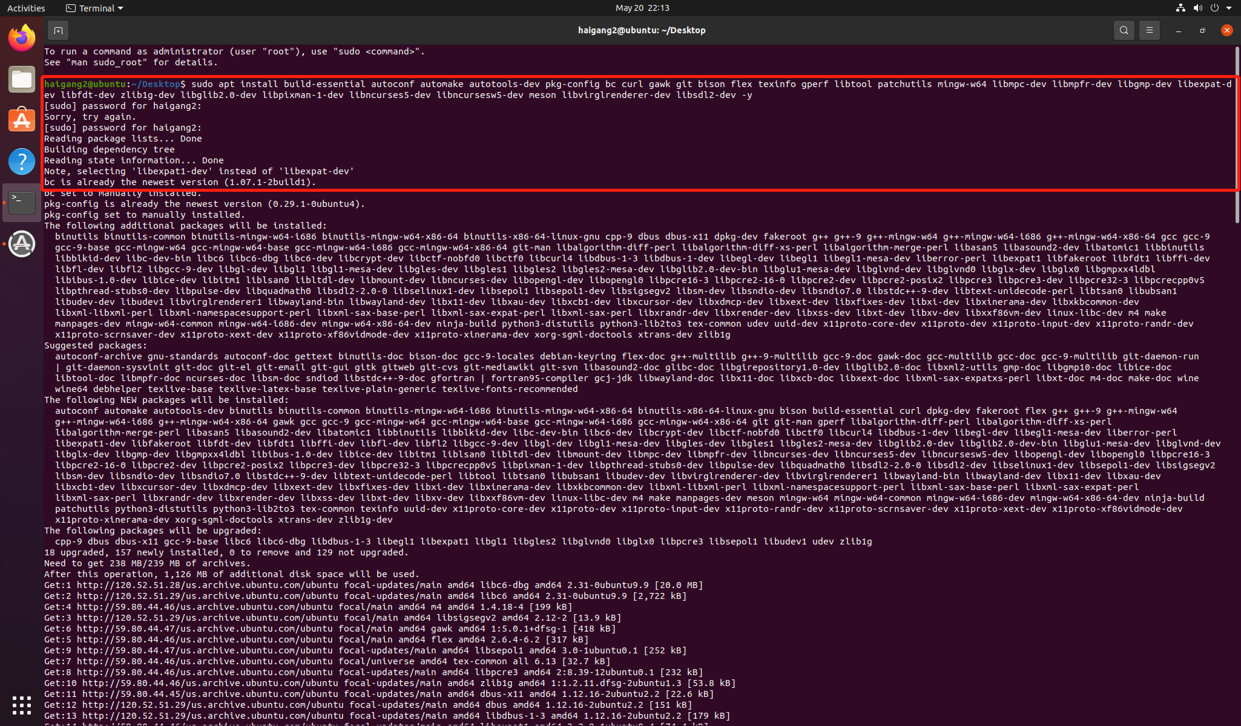

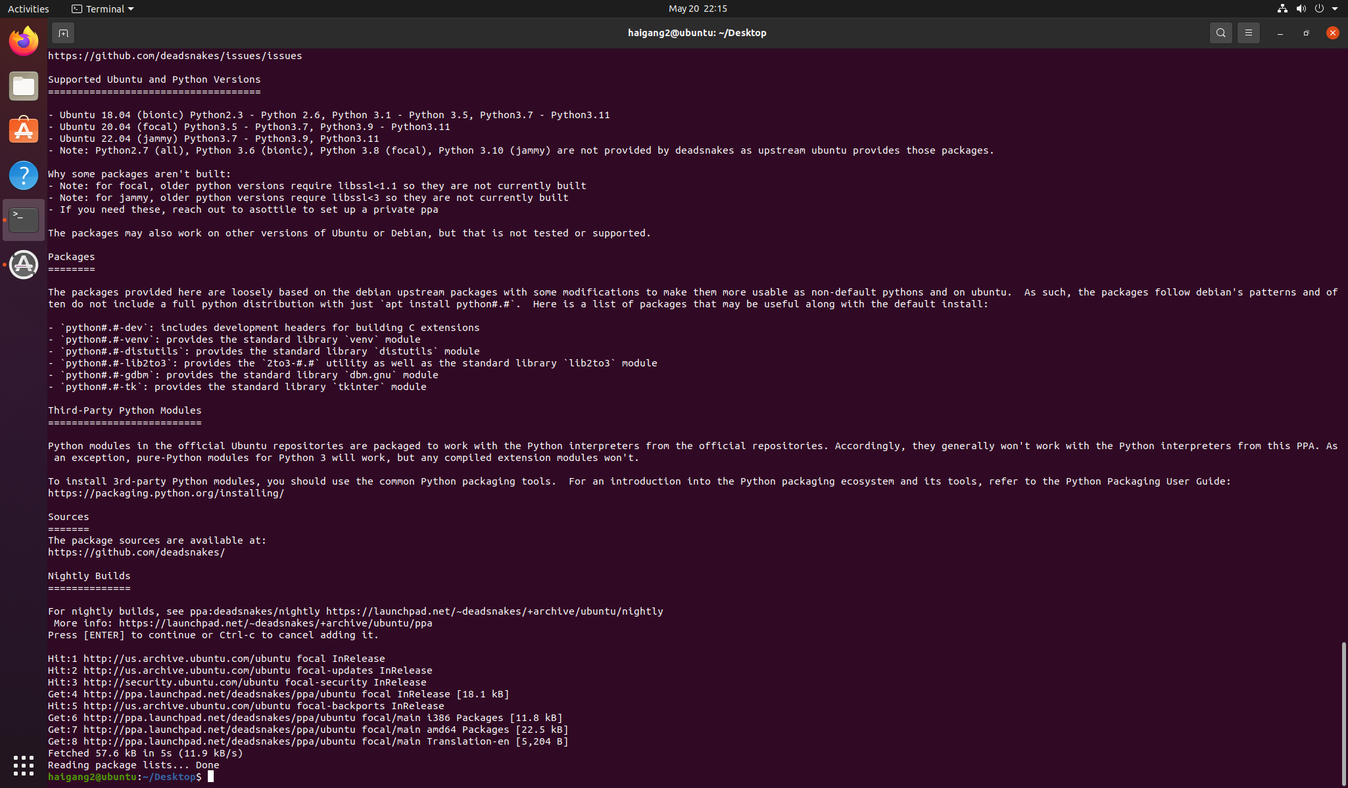

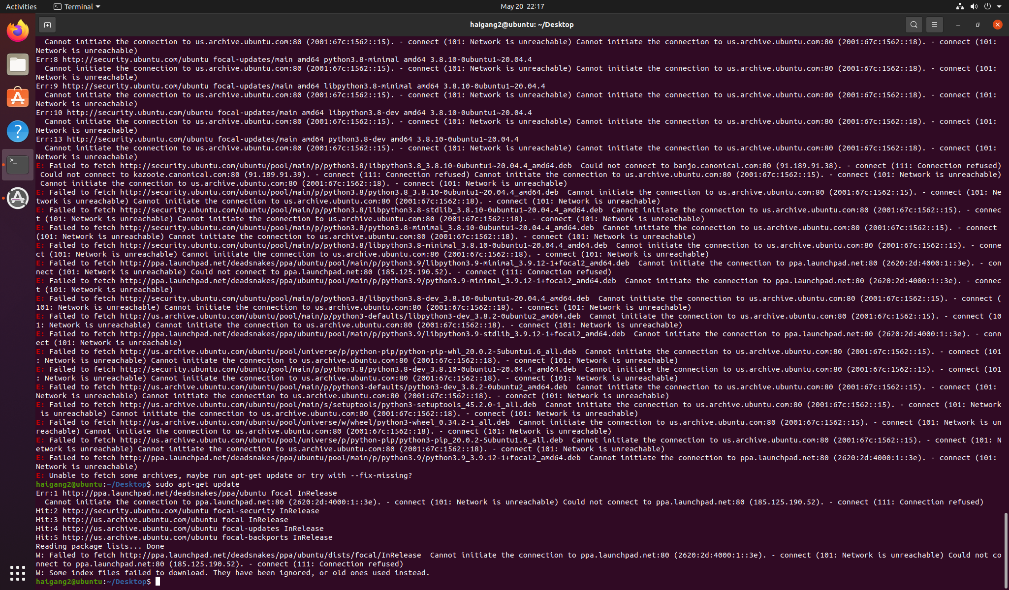

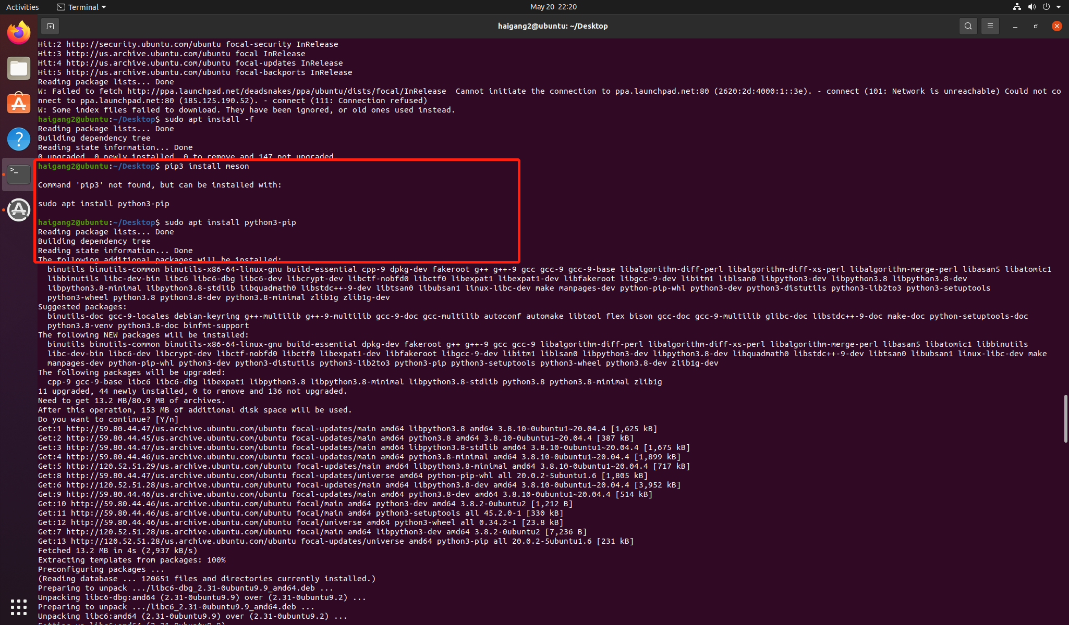

下载支持视频输出QEMU 源码包

git clone -b display <https://gitlab.com/wangjunqiang/qemu.git>

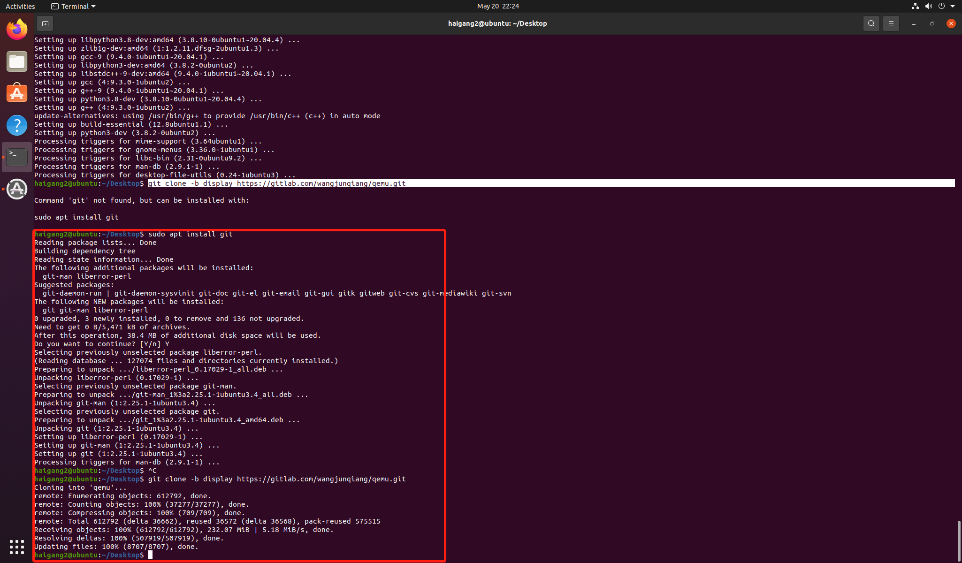

cd qemu

git submodule init

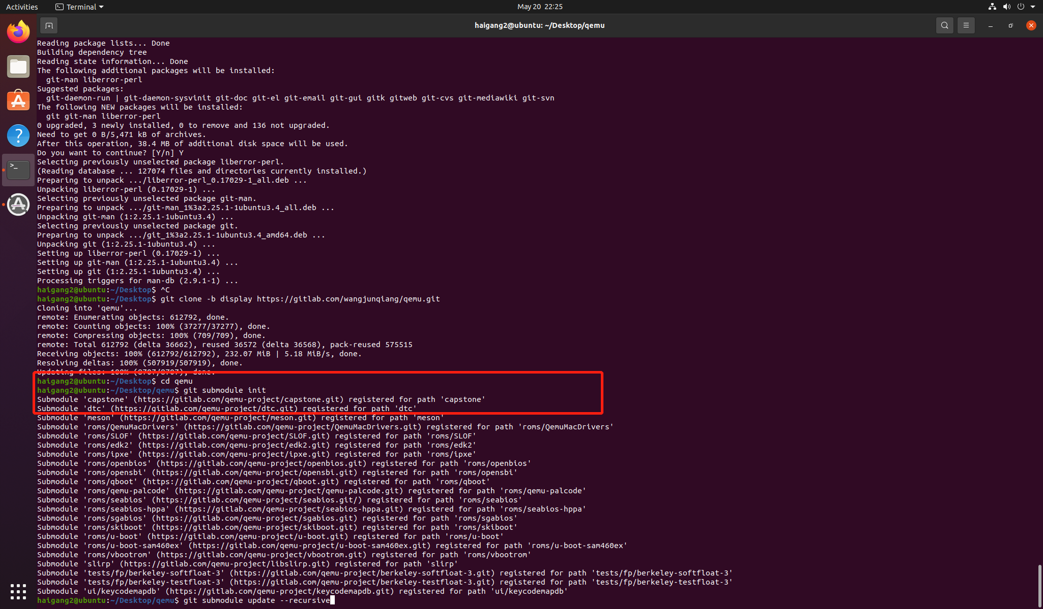

git submodule update --recursive

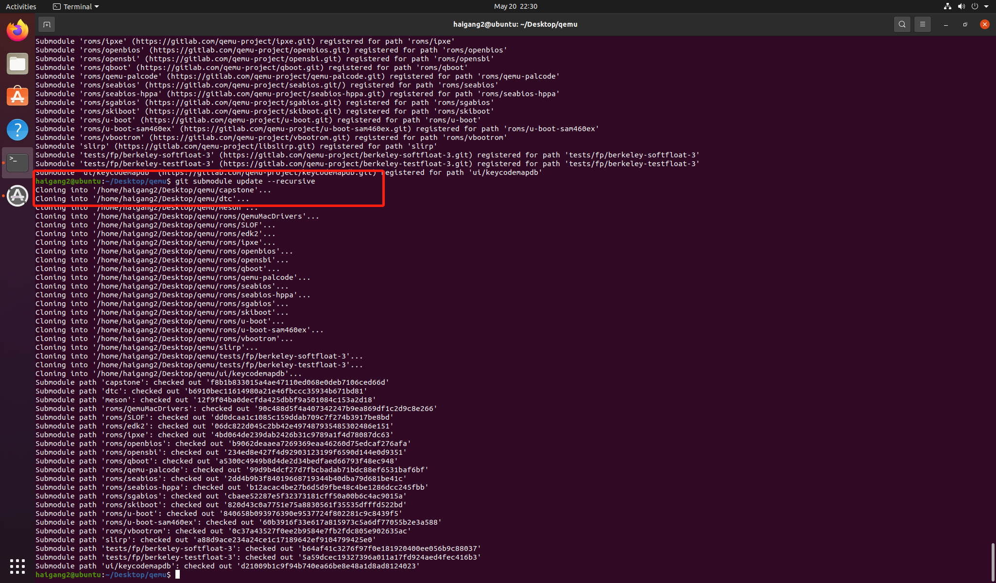

mkdir build

cd build

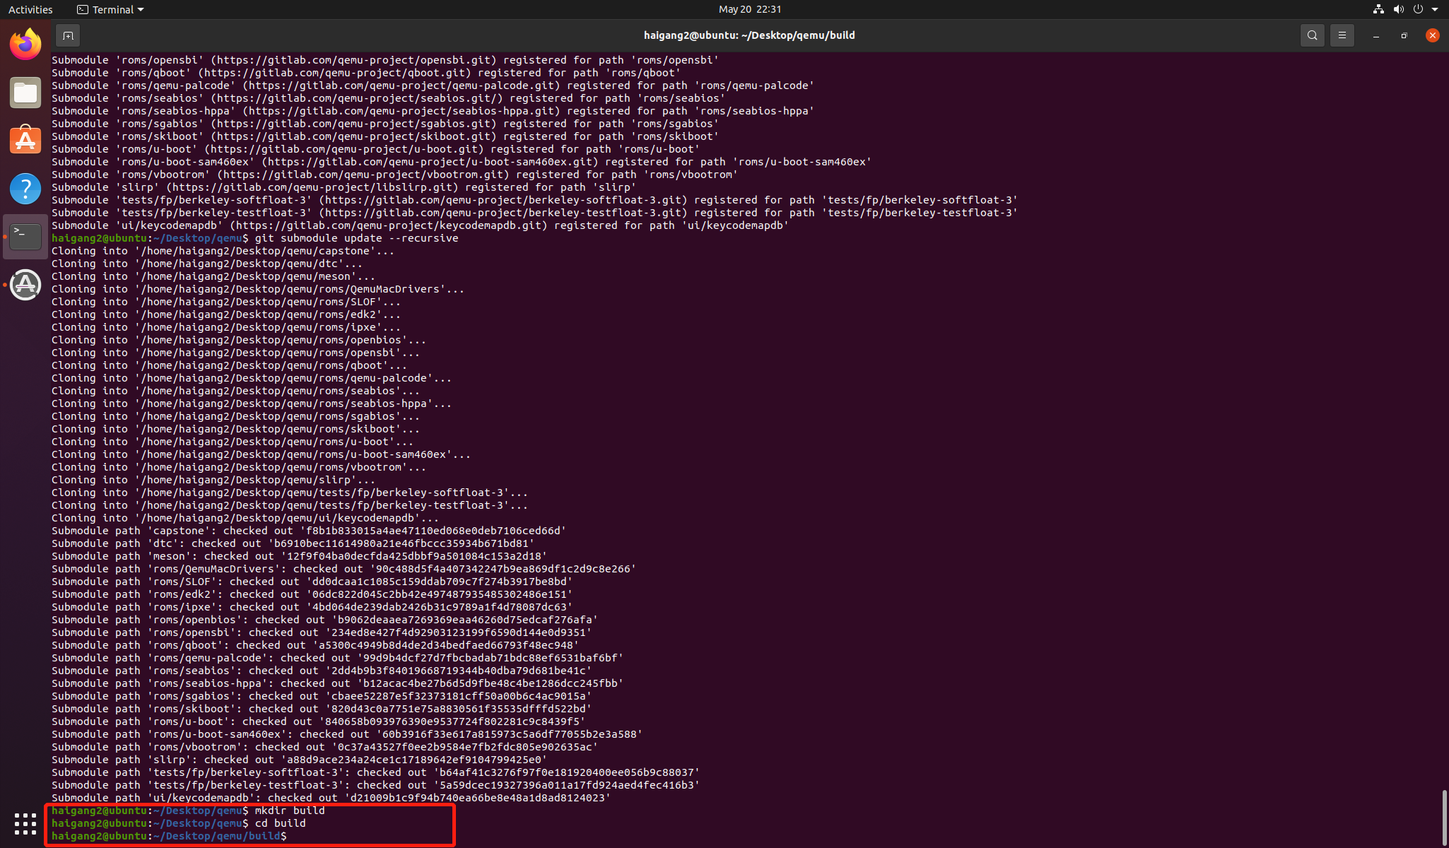

配置riscv64-qemu

../configure --enable-kvm --enable-sdl --enable-gtk --enable-virglrenderer --enable-opengl --target-list=riscv64-softmmu,riscv64-linux-user --prefix=/home/haigang2/Desktop/qemu

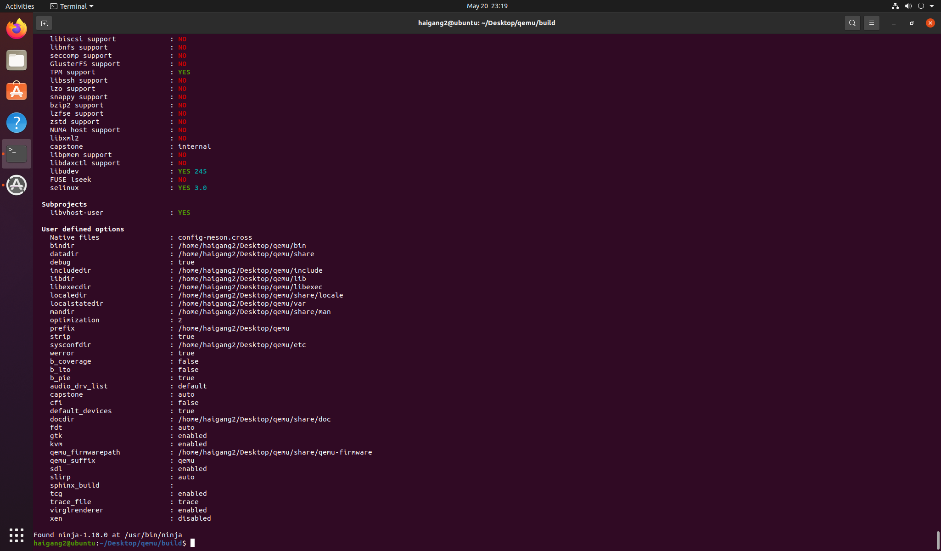

编译

make -j $(nproc)

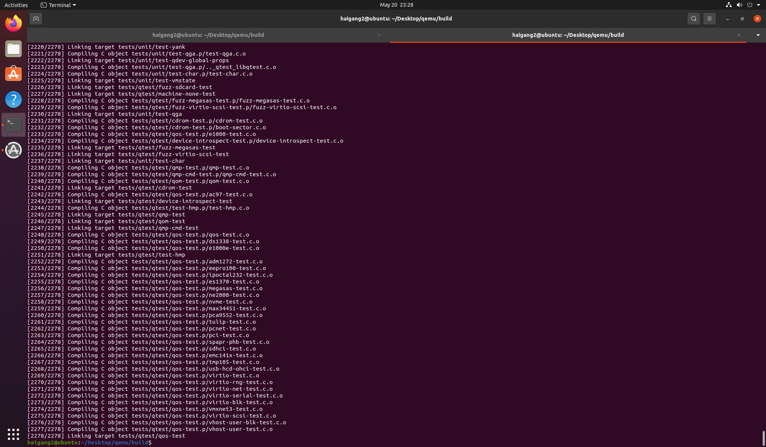

make install

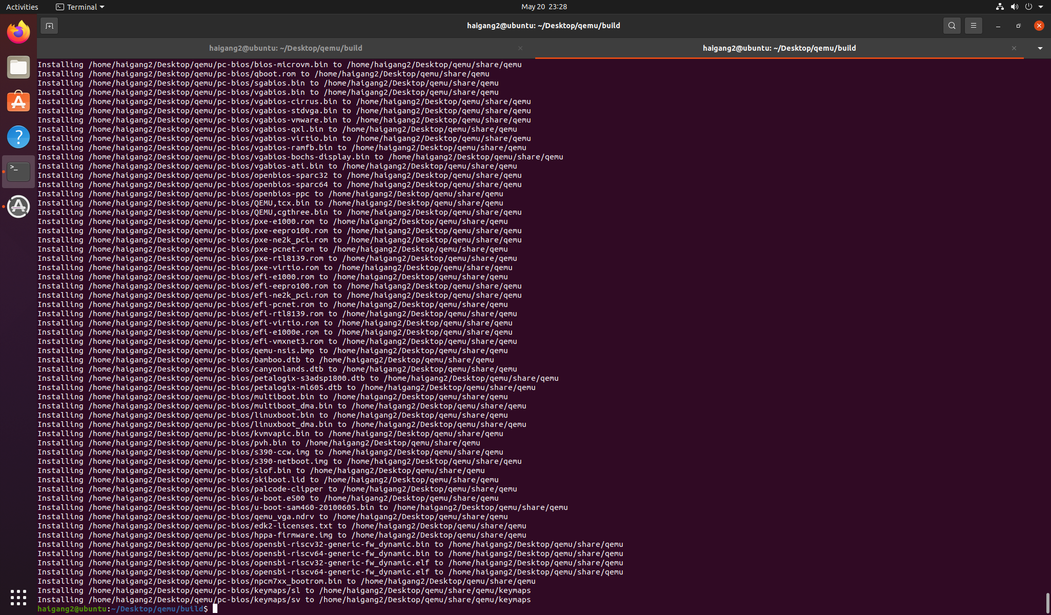

Ubuntu上配置环境变量

vim ~/.bashrc

export QEMU_HOME=/home/haigang2/Desktop/qemu

export PATH=$QEMU_HOME/bin:$PATH

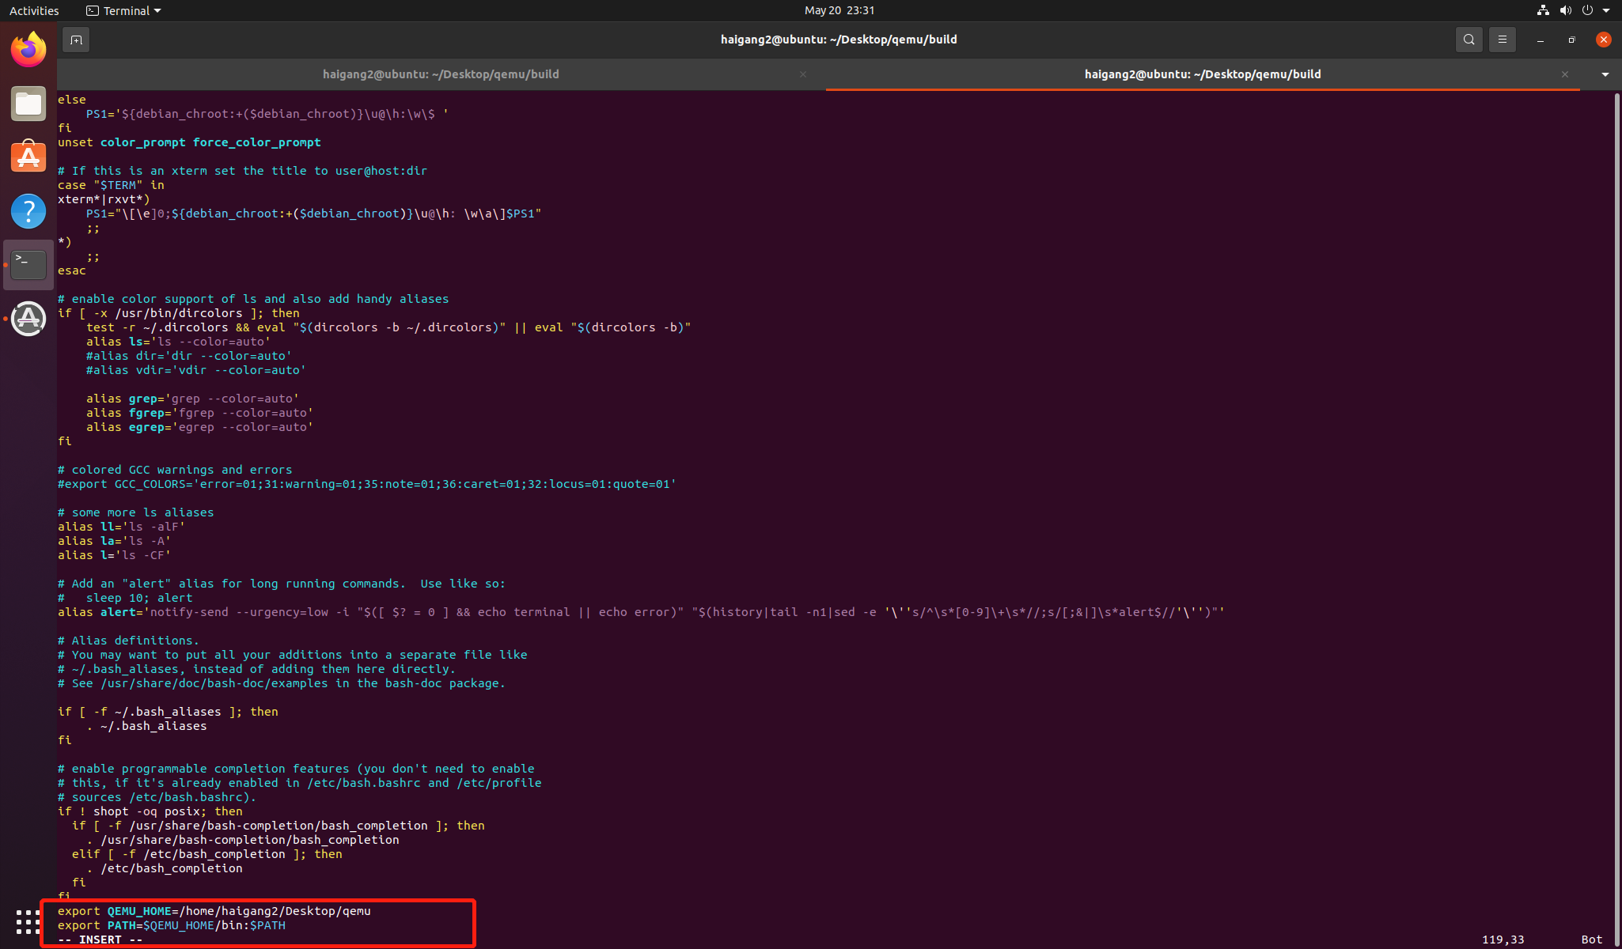

检查是否添加成功

source ~/.bashrc

echo $PATH

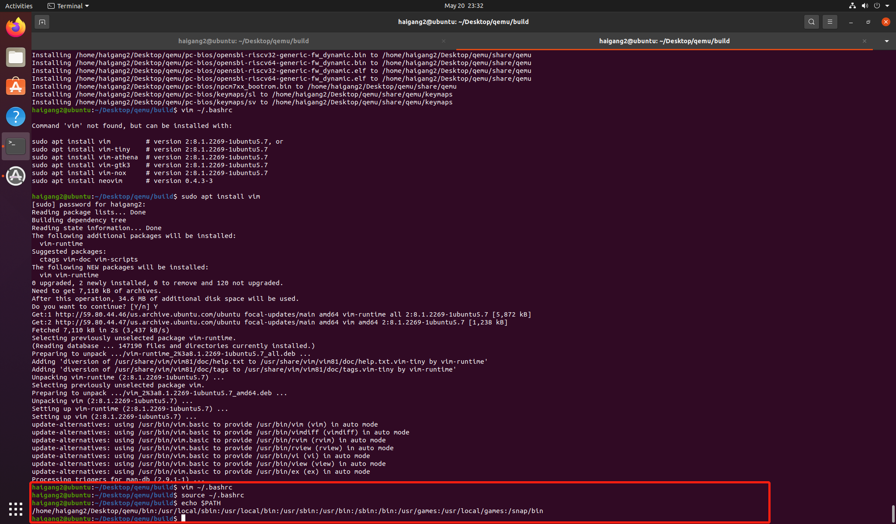

验证安装是否正确

qemu-system-riscv64 --version

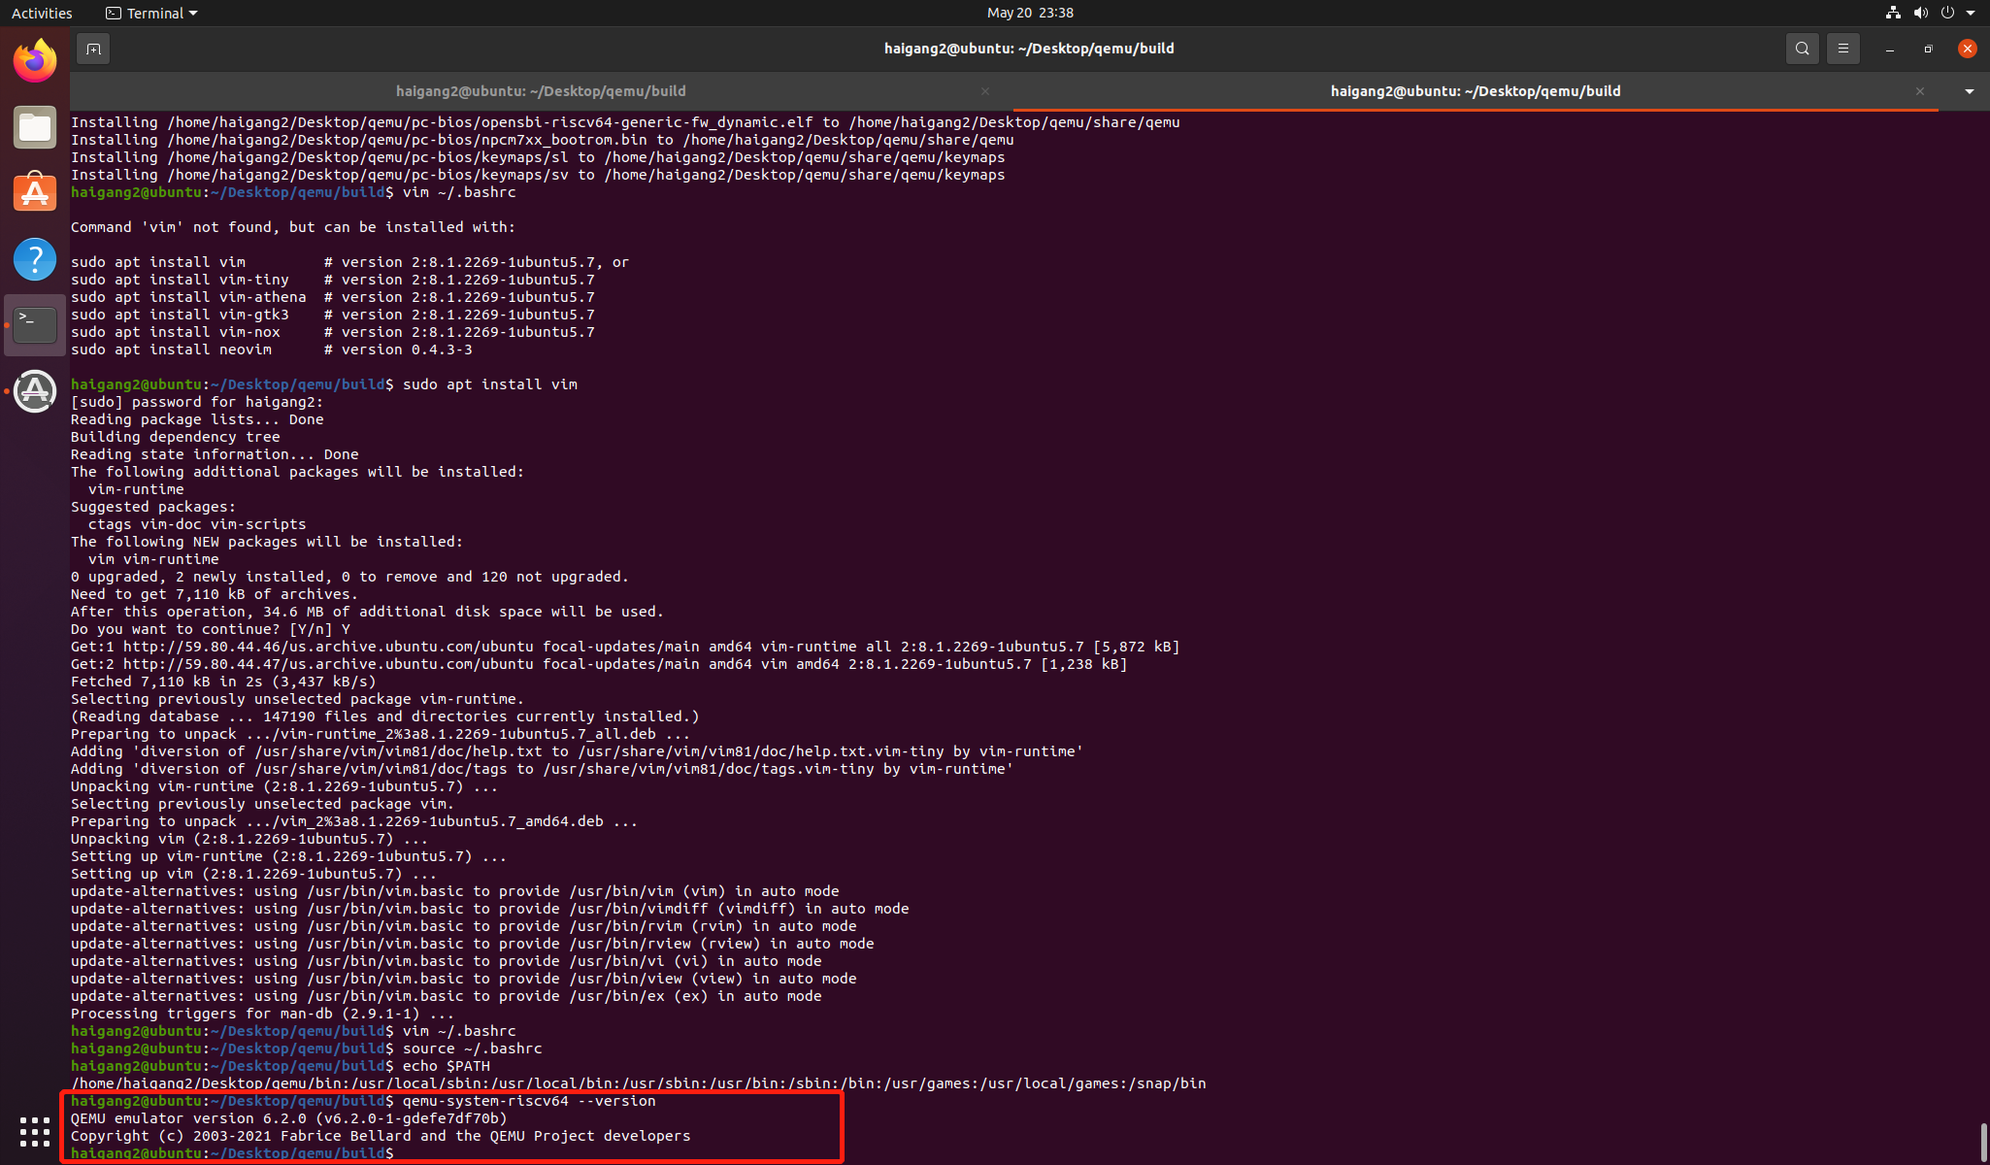

### **下载 编译支持视频输出的 kernel**

### **git clone https://gitee.com/yunxiangluo/riscv-openeuler.git**

### **cp ./riscv-openeuler/chapter3/class1/Image .**

### 

### **下载openeuler**

wget --no-check-certificate https://mirror.iscas.ac.cn/openeuler-sig-riscv/openEuler-RISC-V/development/2203/Image/openEuler-22.03.riscv64.qcow2

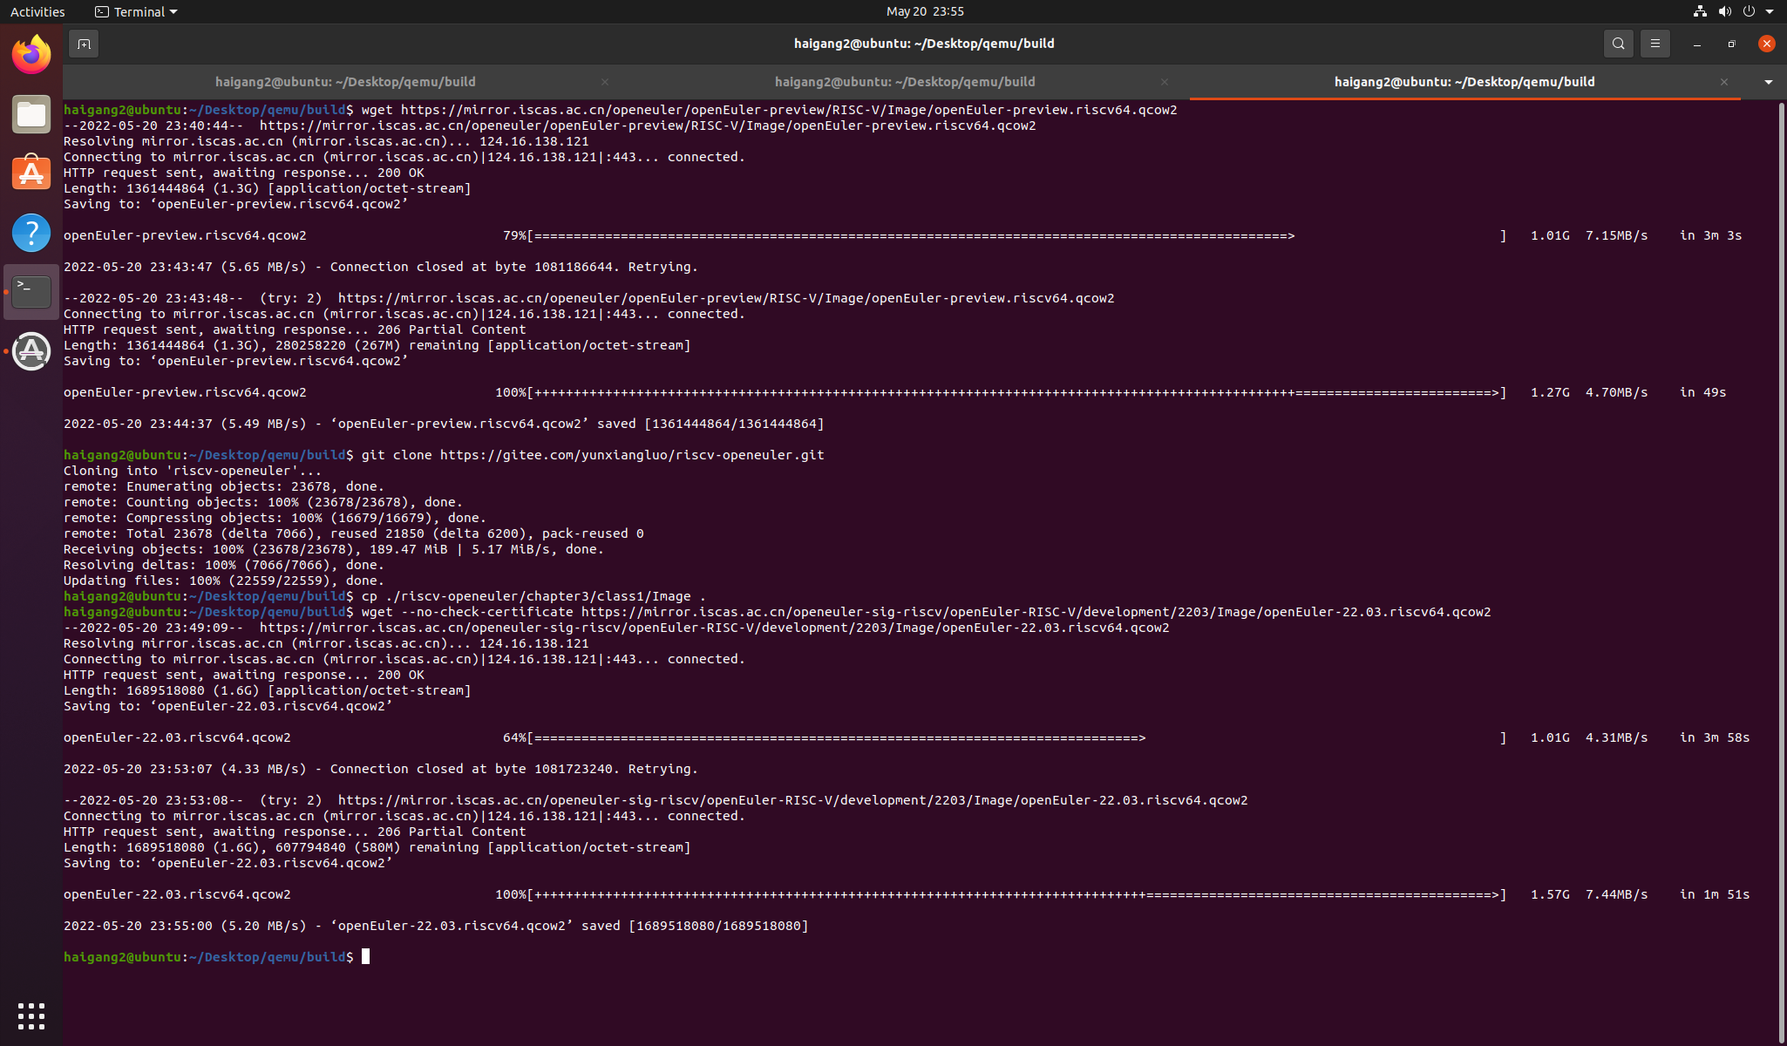

QEMU启动RISC-V openEuler

#!/usr/bin/bash

qemu-system-riscv64 \

-nographic -machine virt \

-smp 8 -m 4G \

-display sdl -vga std \

-kernel Image \

-append "loglevel=3 swiotlb=1 console=ttyS0 rw root=/dev/vda1" \

-drive file=openEuler-22.03.riscv64.qcow2,format=qcow2,id=hd0 \

-object rng-random,filename=/dev/urandom,id=rng0 \

-device virtio-rng-device,rng=rng0 \

-device virtio-blk-device,drive=hd0 \

-device virtio-net-device,netdev=usernet \

-netdev user,id=usernet,hostfwd=tcp::12055-:22 \

-device qemu-xhci -device usb-tablet -device usb-kbd

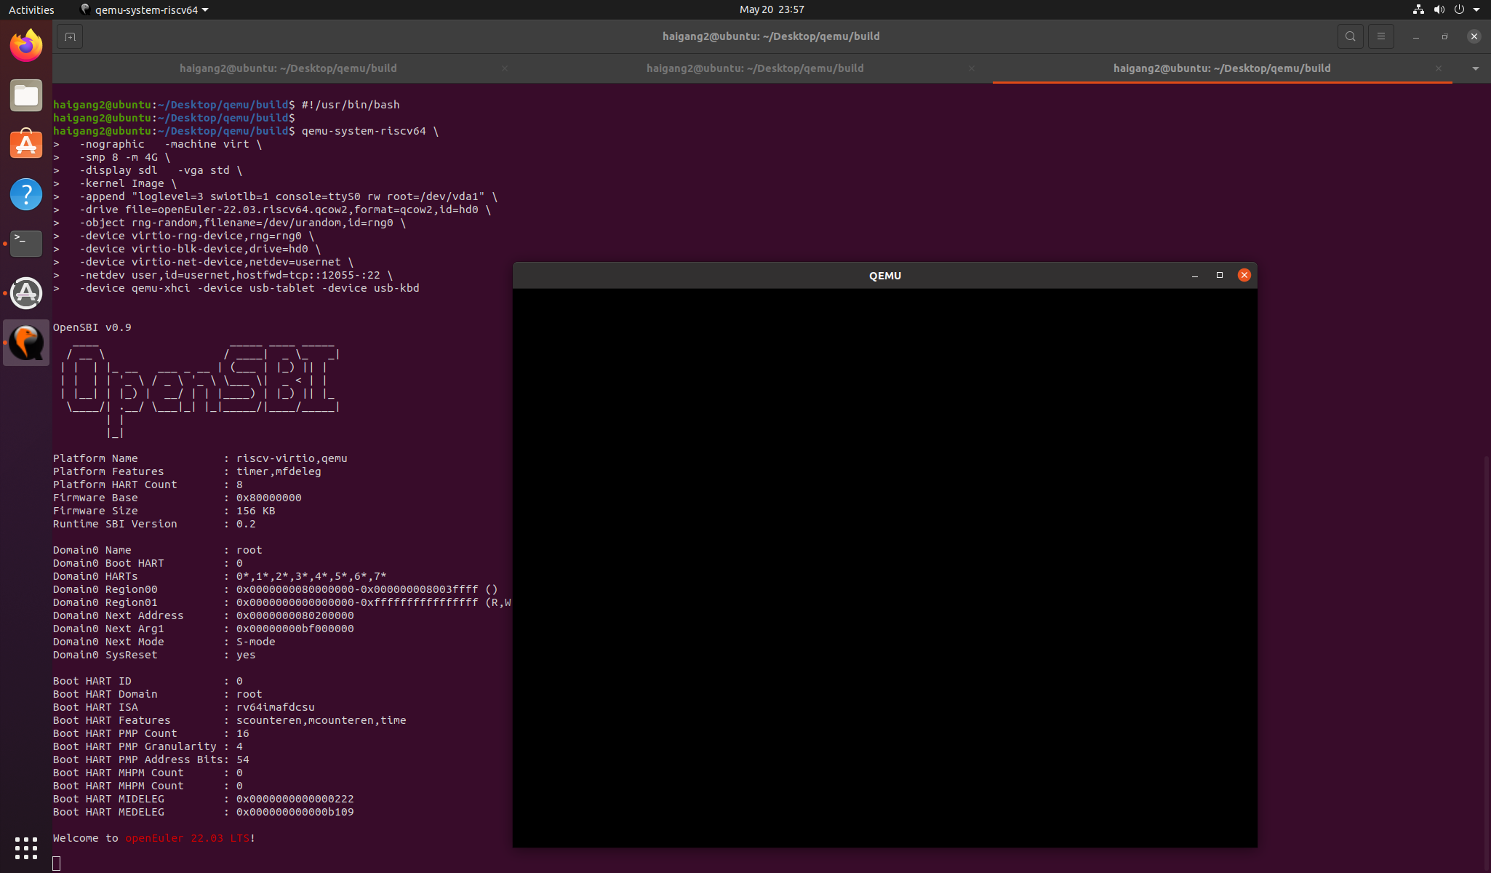

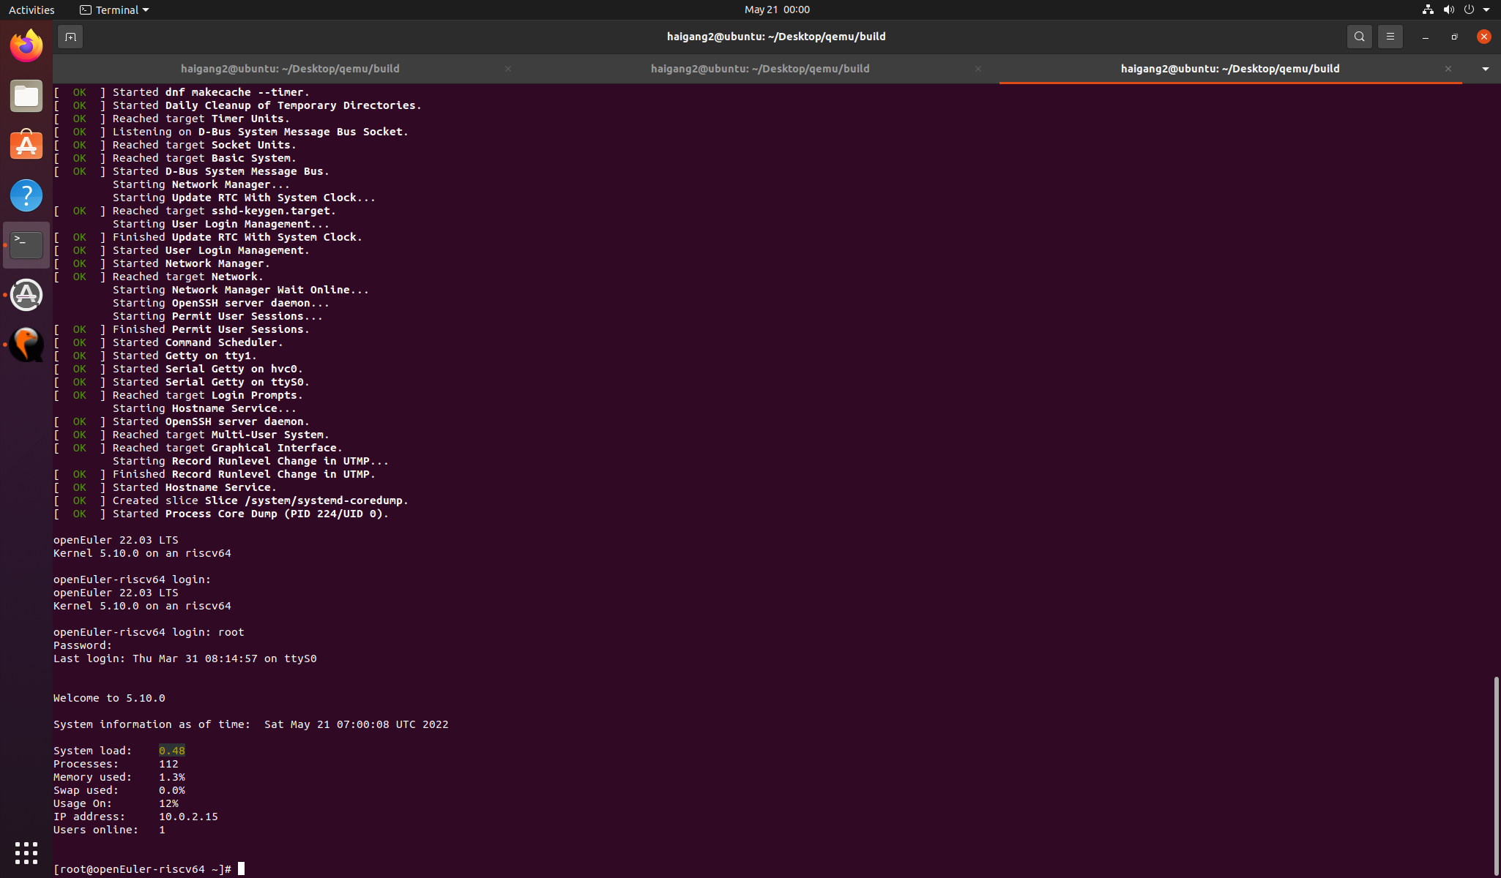

添加xfce软件源

vim /etc/yum.repos.d/openEuler.repo

[22.03]

name=22.03

baseurl=http://obs-backend.tarsier-infra.com:82/openEuler:/22.03/openEuler_2203/

enabled=1

gpgcheck=0

[22.03Epol]

name=22.03Epol

baseurl=http://obs-backend.tarsier-infra.com:82/openEuler:/22.03:/Epol/openEuler_22.03_Epol/

enabled=1

gpgcheck=0

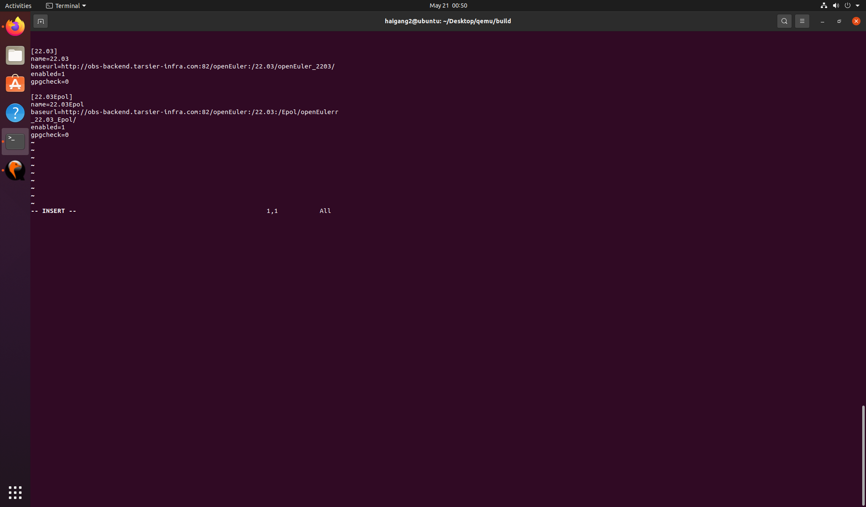

安装 xfce4

yum install libxfce4util xfconf libxfce4ui exo garcon thunar thunar-volman tumbler xfce4-appfinder xfce4-panel xfce4-power-manager xfce4-settings xfdesktop xfwm4 xfce4-session xfce4-terminal -y

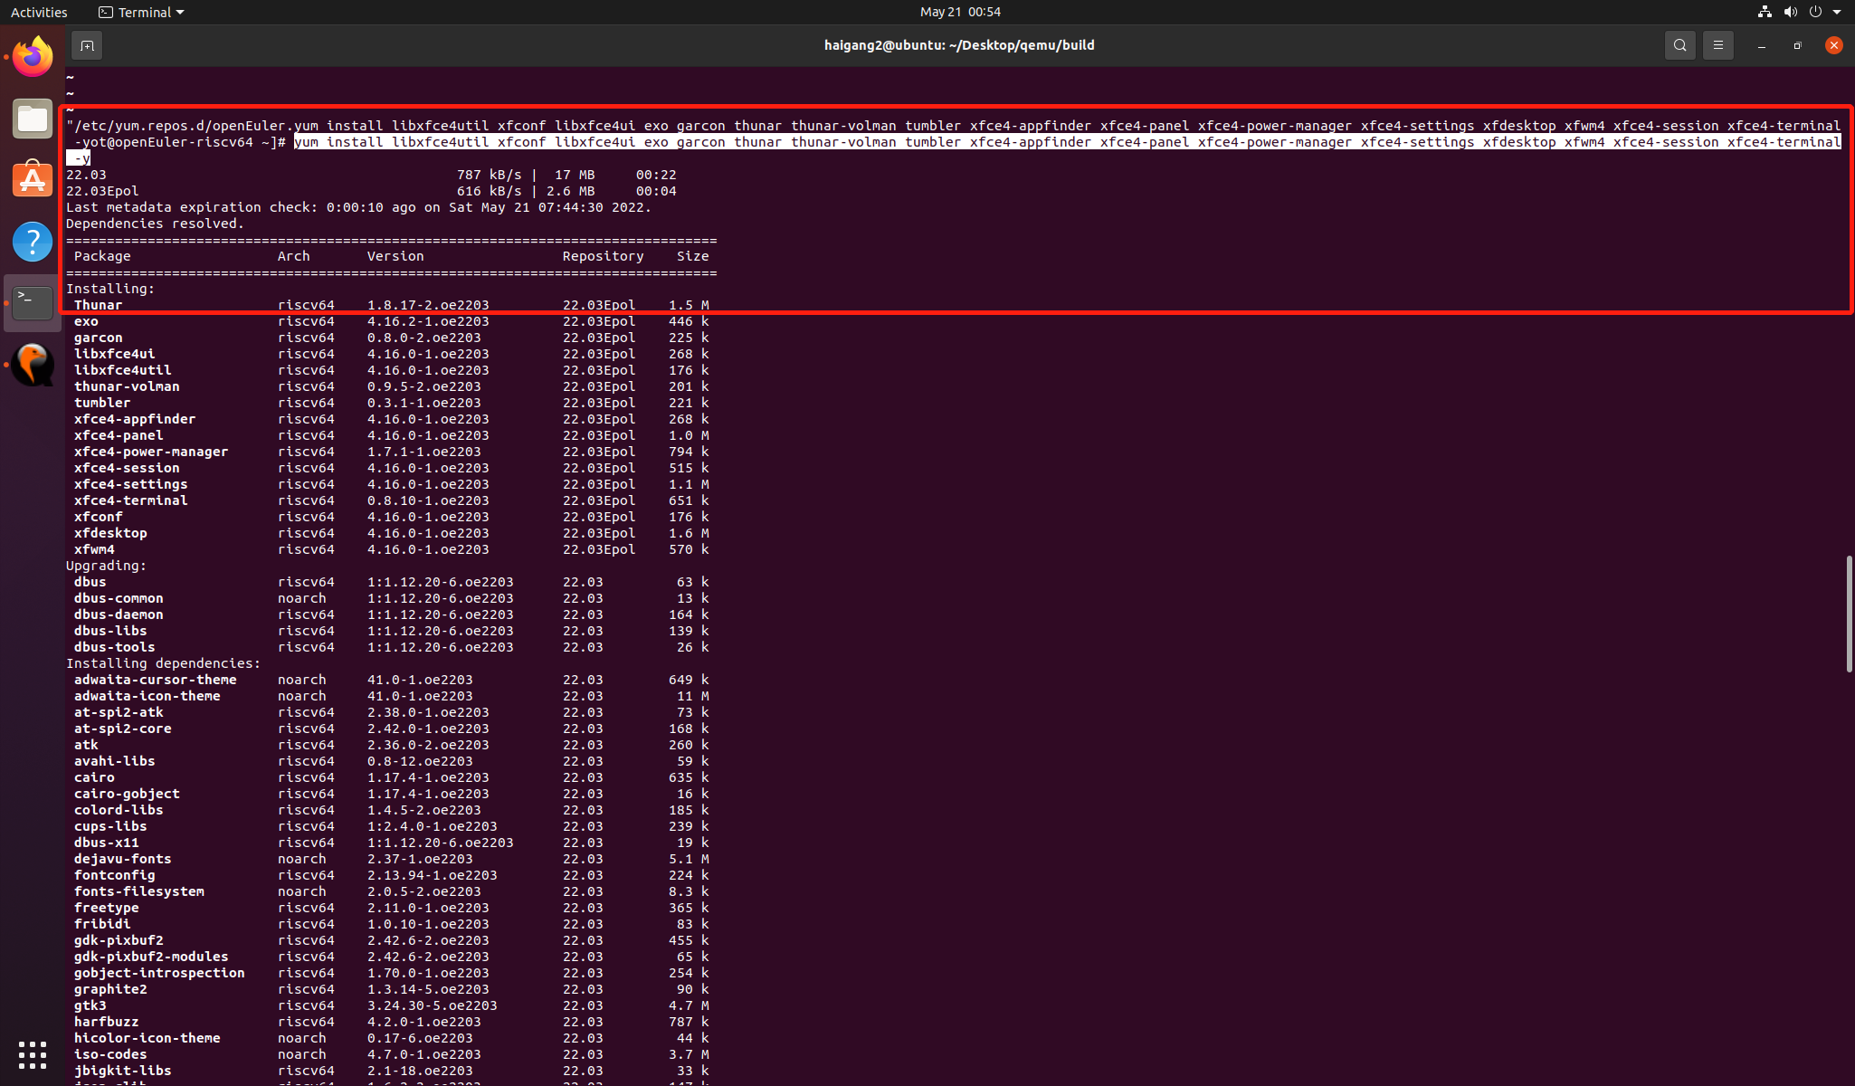

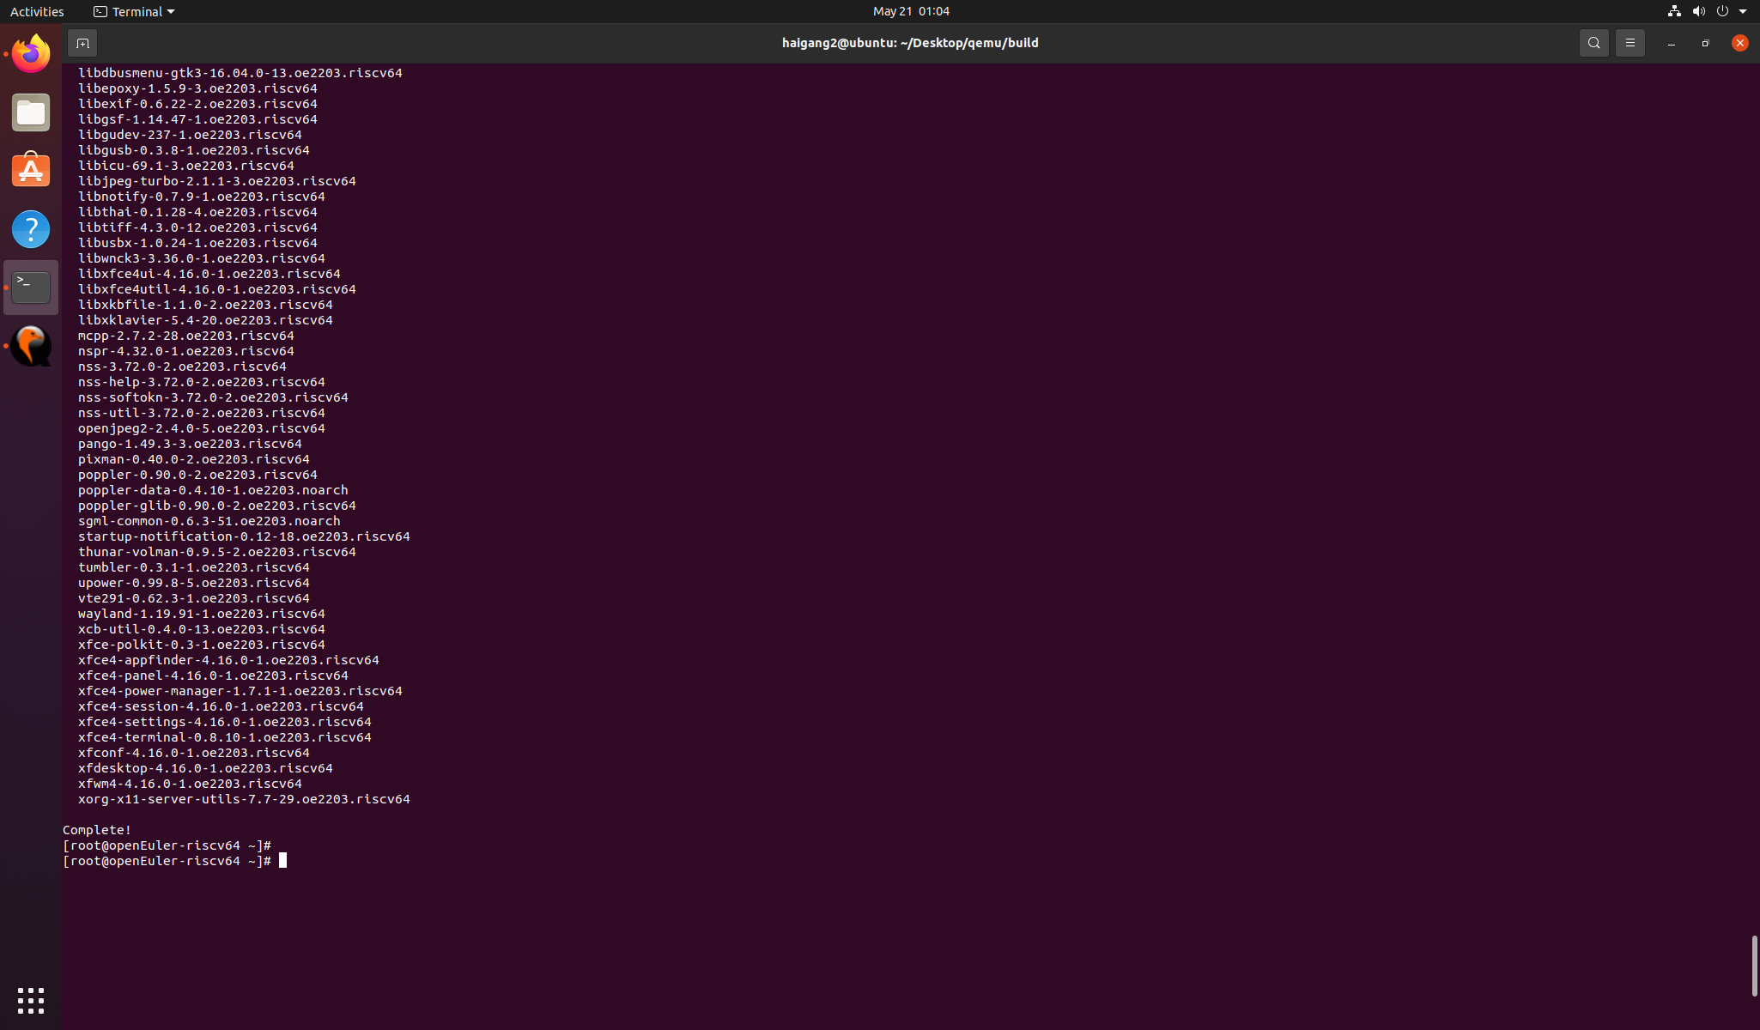

yum install xorg-x11-xinit xorg-x11-server -y

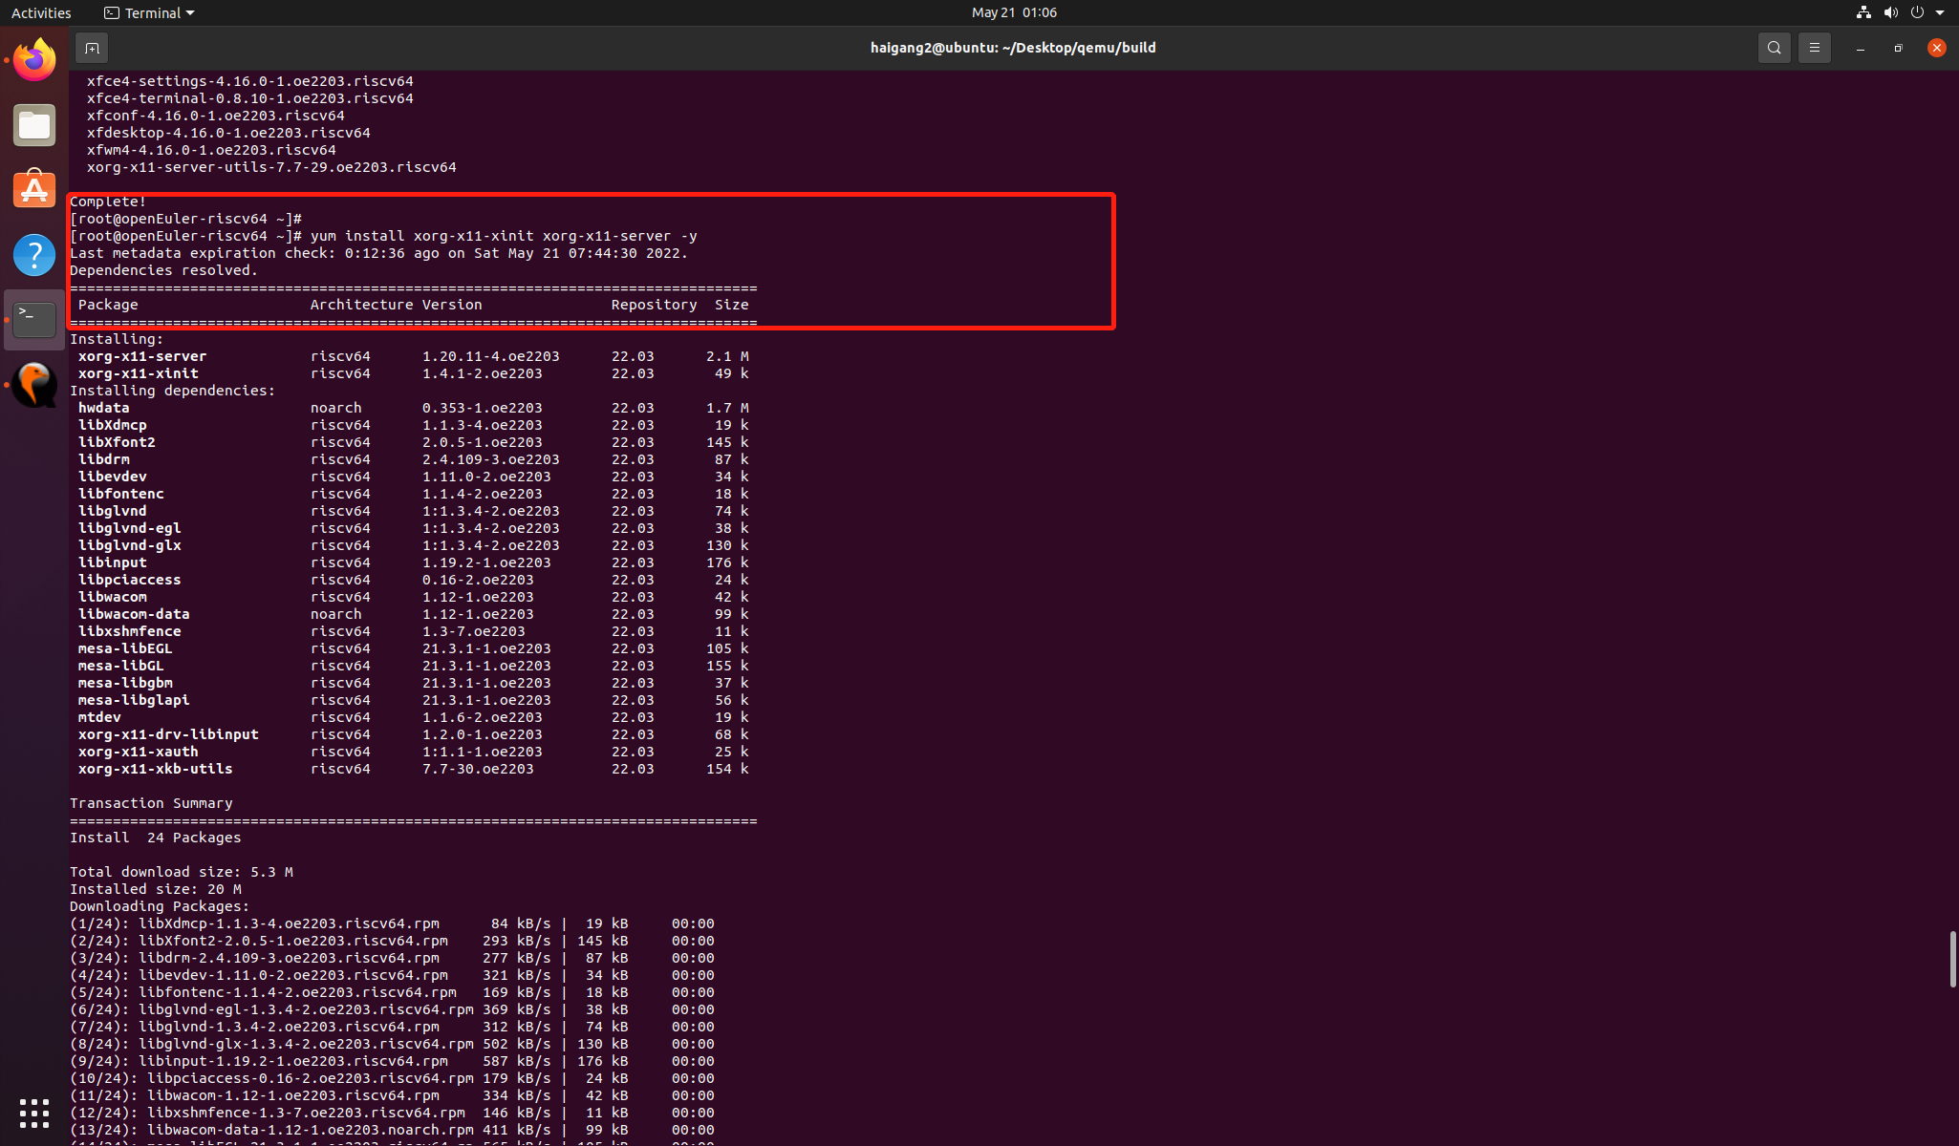

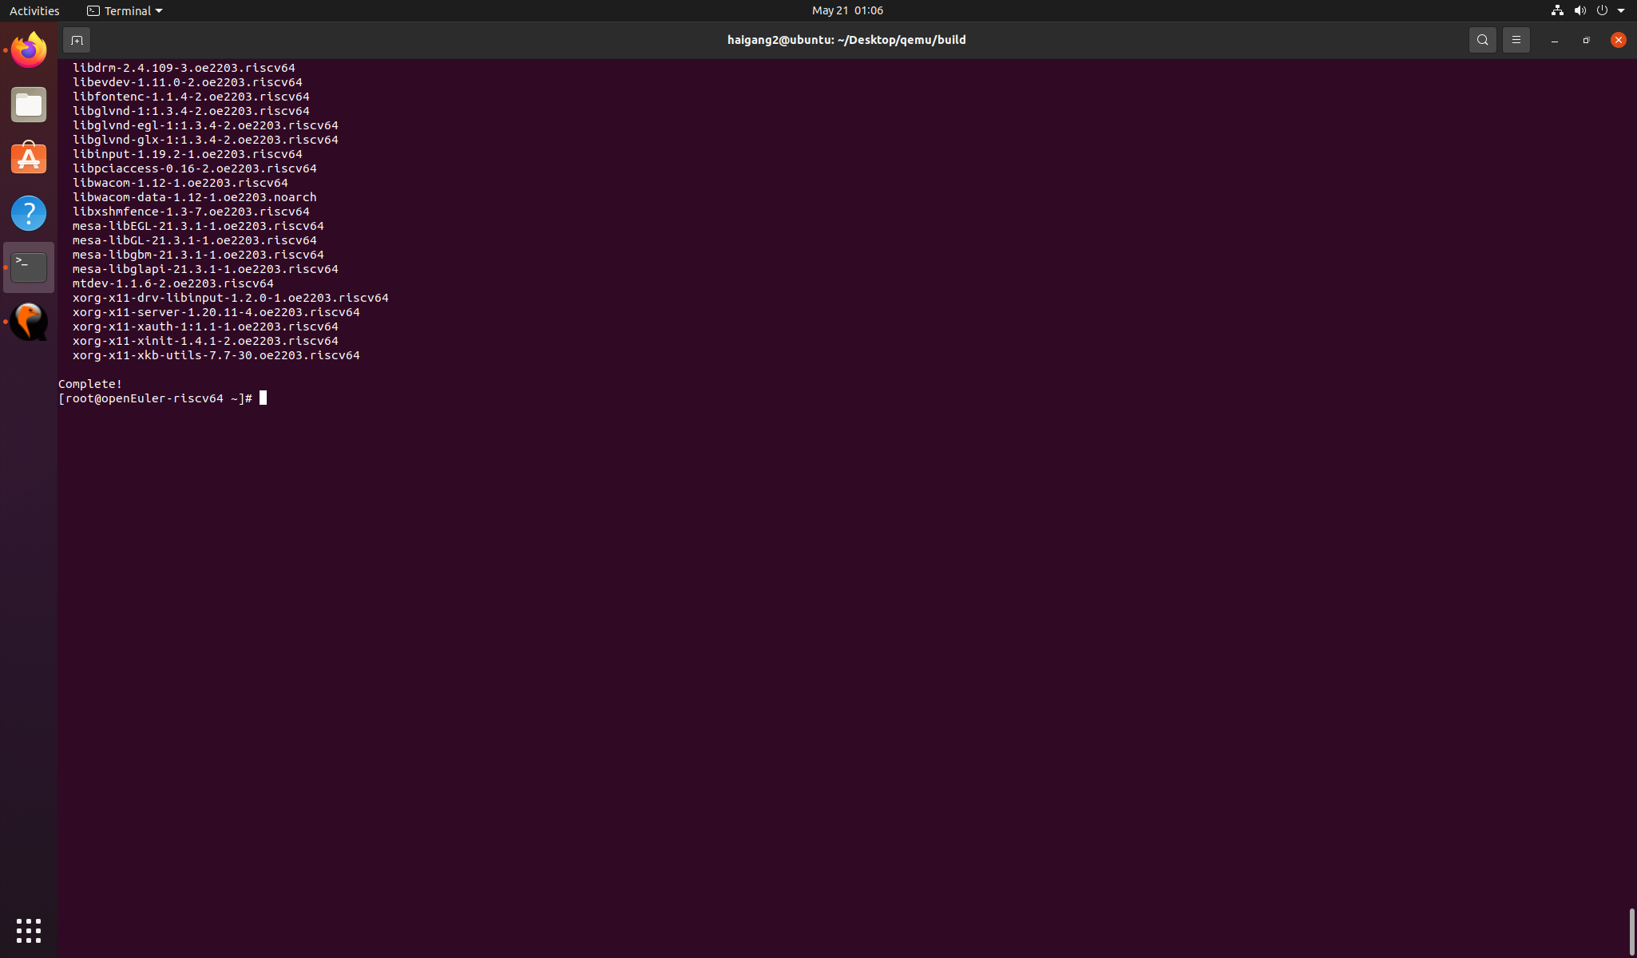

dnf upgrade pango

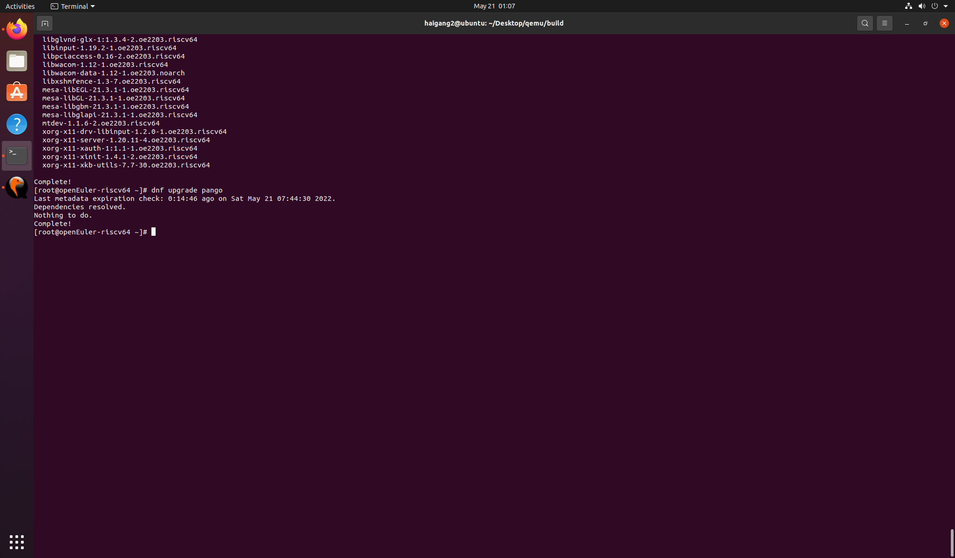

startxfce4

